MODIFICATION TO X-MOTOR POWER LEADS

- PARTS:

QUANTITY: PARTS: NOMENCLATURE: LENGTH:

1 PER MACHINE 211032- REWORK OF X-AXIS MOTOR 18681-2 N/A

1 PER MACHINE 17024- CONNECTOR, 2-PIN MALE N/A

2 PER MACHINE 17022- PIN, CONNECTOR N/A

1 PER MACHINE 46776- SLEEVE, ¼” BLACK 7.5 INCHES

2. ASSEMBLY:

- CUT THE RED AND BLACK WIRES TO 8 INCH LENGTHS.

- SLIDE THE SLEEVING OVER THE WIRES.

- STRIP 1/8” OF INSULATION FROM THE ENDS OF THE WIRES.

- CRIMP AND TIN THE PINS TO THE WIRES ACCORDING TO DIAGRAM 1.

- INSERT THE PINS INTO THE CONNECTOR ACCORDING TO DIAGRAM 2.

NOTE 1
IT IS CRITICAL TO INSERT THE PINS IN THE CORRECT COLOR ORDER. ANY VARIATION MAY CAUSE DAMAGE TO THE MOTOR OR TO THE MACHINE.



DIAGRAM 1

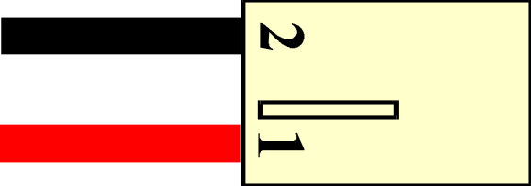

DIAGRAM 2

